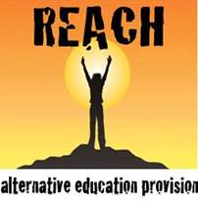
Staff observation report / feedback
REACH staff member

Name of person carrying out observation from REACH / School / Agency
Observations against the Core Offer expectations of our staff | A therapeutic approach that aims to help revisit gaps in childhood play learning & development  Professional motivated staff who strive to deliver the very best  Value for money quality programmes tailored to individual and group needs  Group provisions that focus on self-confidence, engagement in education, attendance, motivation, social interaction and resilience through activity, life skills, play, group work and mentoring  Our commitment to deliver what we have promised to deliver  A focus on learning & personal development throughout  Partnership working, with home visits and attendance to meetings where required  Safeguarding at the core of our work in conjunction with Somerset Safeguarding Board policies & The Department for Education, Keeping children safe in education document – July 2015  Feedback documents for every student session delivered  Fully risk assessed, insured and well managed projects with student safety paramount throughout  Responsive telephone, email and site visits, in reply to communications and requests of any assistance  A quality assurance visit / review upon request  A quick, fair and open response to any complaints or issues raised  Time together to reflect and evaluate the work and partnership itself.
Programme plan / aims / relation to attainment objectives

General observations of the worker & session

Any other comments / improvement areas / training needs

Signature of individual completing observation

Date of report completion

